### **Go-daddyGodaddy Email Setup for Android Phone**

# ***Mail server addresses and ports for Business Email Depending on Region***

### **Europe**

|  |  |
| --- | --- |
| **Type** | **Server Address** |
| **Incoming** | **imap.europe.secureserver.net** |
| **Outgoing** | **smtpout.europe.secureserver.net** |

### **Asia**

|  |  |
| --- | --- |
| **Type** | **Server Address** |
| **Incoming** | **imap.asia.secureserver.net** |
| **Outgoing** | **smtpout.asia.secureserver.net** |

### **Americas**

|  |  |
| --- | --- |
| **Type** | **Server Address** |
| **Incoming** | **imap.secureserver.net** |
| **Outgoing** | **smtpout.secureserver.net** |

### **Ports**

|  |  |  |
| --- | --- | --- |
| **Type** | **non SSL** | **SSL** |
| **Incoming (IMAP)** | **143** | **993** |
| **Outgoing (SMTP)** | **80, 3535, 25** | **465, 587** |

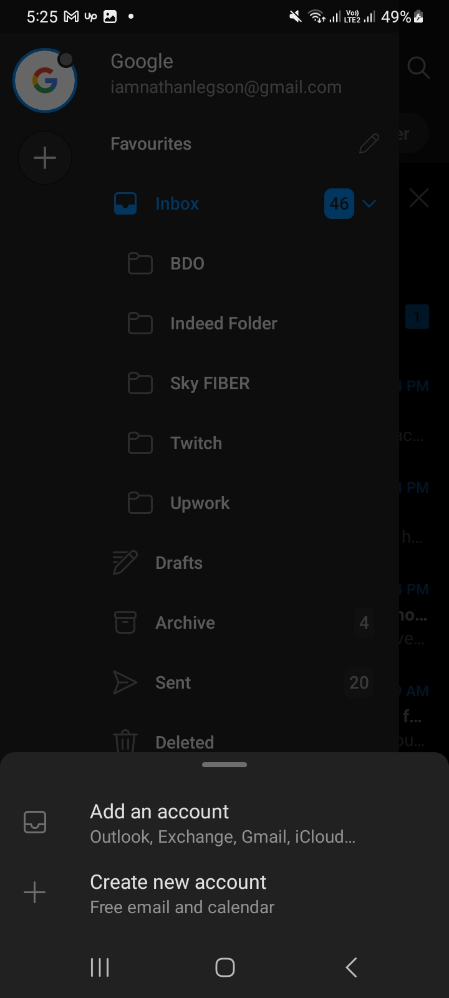**1.)Open Outlook Mobile App on your phone.**

**2.)Click on the plus sign on the upper left corner it may look different for other-version of**

**Android phones.**

**3.)Select on “ADD AN ACCOUNT”**

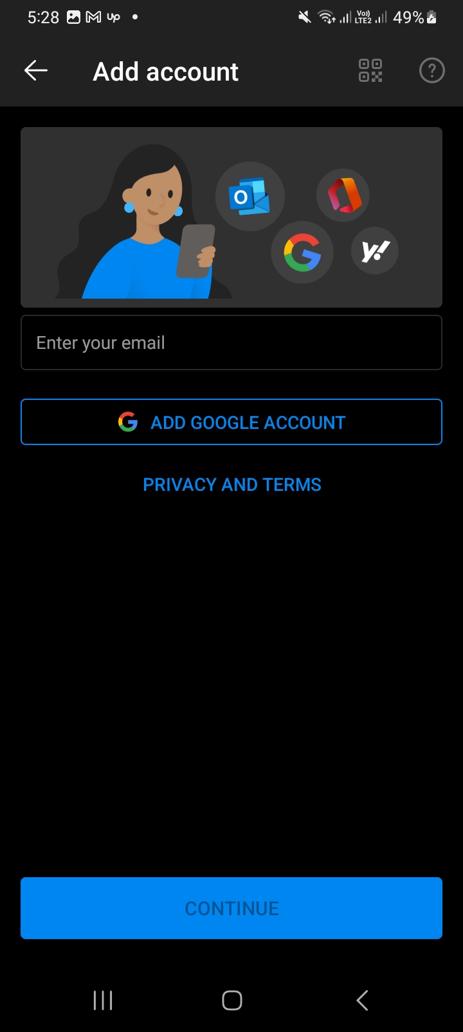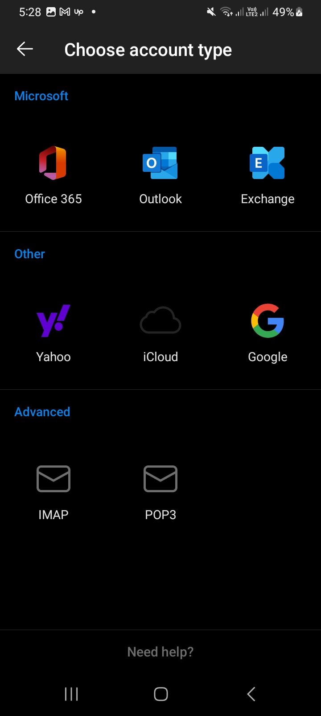

1. **Type in you Godaddy Email address and Click continue**
2. **Choose account type and select “IMAP”**

jonathantest@godaddy.com

1. **Complete and confirm the following field below. ( Please refer on the screenshot )**
2. **In your case it should be the Asia Server Address**

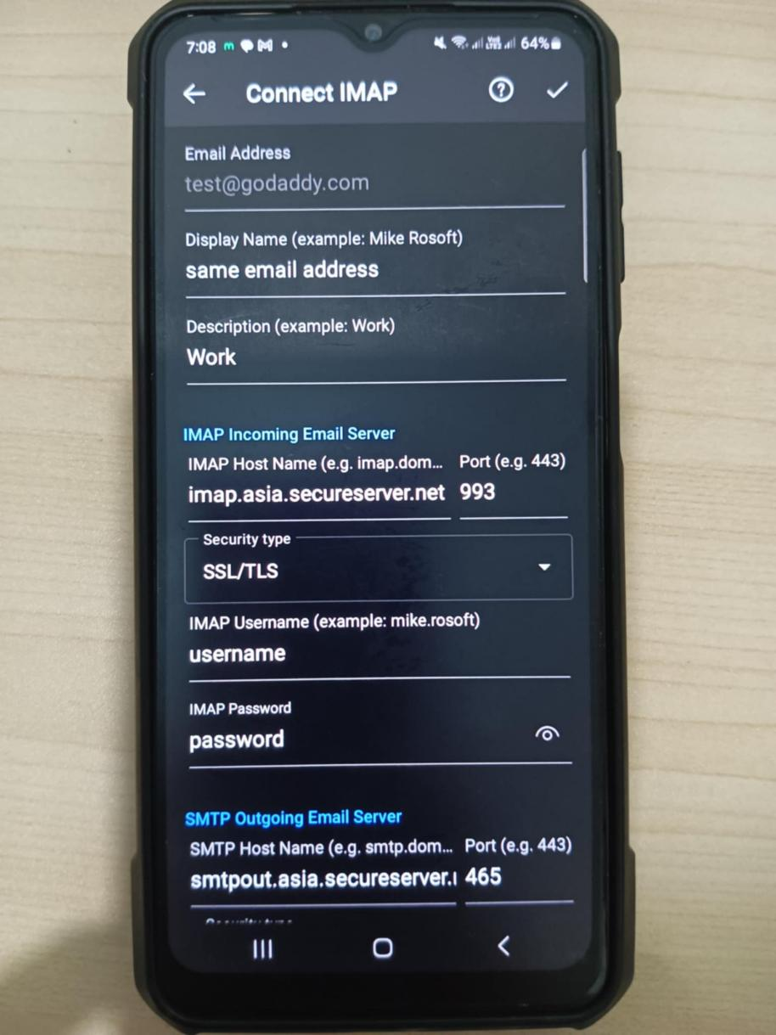

|  |  |
| --- | --- |
| **Field** | **What to enter** |
| **Email address** | jonathantest@godaddy.com |
| **Username** | Your full Business Email address, again |
| **Password** | Your Business Email password |
| **IMAP server** | **imap.asia.secureserver.net** |
| **Security type and Port** | If you choose **SSL**, enter **993**. If you choose **None**, enter **143**. |
| **IMAP path prefix** | Leave this blank |
|  |  |

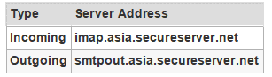

**8.) Once completed and added the account kindly do a test message**

**for the confirmation.**